
SERC Mini-OS: Technical Report
Operating System Simulation

LECTURER: DR Ntalasha

Group Members

NAME | SIN
Emmanuel Nkaka | 23130711
Paul Banda | 22103558
Luckson Chama | 22106051

Table Of Content
1) Introduction 3
1.1) Objectives 4
2) Development Steps 5
2.1) Prerequisites 5
3) System Architecture and Data Structures 5
4) Algorithms Implemented 7
4.1) Creating the GUI with GTK 9
4.2) Creating the Installer with Inno Setup 10
5) Expected Output 18
6) Current Limitations 19
7) Conclusion 20

Introduction
Operating systems are fundamental to modern computing, yet their internal workings remain abstract and difficult for students to grasp through theoretical study alone. Traditional textbook explanations of process scheduling, memory management, deadlock avoidance, and inter-process communication often fail to convey the dynamic interactions between these subsystems.
Mini-OS Monitor is a tool that simulates core OS components including process management, CPU scheduling, memory allocation, deadlock prevention via Banker's algorithm, and inter-process communication mechanisms. Built with the C programming language and GTK+3 graphical toolkit, the application provides both command-line feedback and rich visualizations such as Gantt charts for scheduling and block diagrams for memory mapping.
The system is designed for use in operating systems courses, allowing instructors to demonstrate algorithms in real-time and experiment with different scheduling policies, resource allocation strategies, and IPC methods. By providing immediate visual feedback and performance metrics.

1.1) Objectives
The Mini-OS for SERC following operating system components:
Table: Checklist
Component | Implementation Status
Process Management
CPU Scheduling (2+ algorithms) | FCFS, Round Robin
Memory Management | First-Fit
Inter-Process Communication | Messages, Pipes, Shared Memory
Deadlock Handling | Banker's Algorithm
File Management | Event Logging

Development Steps

Prerequisites
- C Compiler (GCC/MinGW or MSYS2)
- GTK Library (Download and set up)
- Inno Setup (For creating the installer)
- Code Editor (Code blocks)
- GCC Compiler 9.0+
- GTK+ 3.0
- Cairo Graphics (Gantt chart rendering)

System Architecture and Data Structures

PRESENTATION LAYER (GTK+3)
- Create Task
- List Task
- FCFS
- Round Robin
- Banker Algorithms
CORE OS SIMULATION LAYER
- Process Manager (pcb.c)
- Memory Manager (memory.c)
- Scheduler (scheduler.c)
- Banker (banker.c)
- IPC system (ipc.c)
- Logger system (logger.c)
- Memory map (memory_map.c)

Process Control Block (PCB)
typedef struct {
int pid; // Unique Process ID
char name[MAX_NAME_LEN]; // Task name: Ambulance, Fire, Police
int priority; // 1=Highest(Ambulance), 2=High(Fire), 3=Normal(Police)
int burst_time; // Total CPU time needed (ms)
int remaining_time; // Remaining CPU time
int arrival_time; // Emergency arrival time
proc_state_t state; // NEW, READY, RUNNING, WAITING, TERMINATED
int mem_addr; // Allocated memory address
int mem_size; // Memory size allocated (KB)
} pcb_t;

Memory Block (Linked List for First-Fit)
typedef struct mem_block {
int start; // Starting address in KB
int size; // Block size in KB
int free; // 1 = free, 0 = allocated
struct mem_block *next; // Pointer to next block
} mem_block_t; int mem_size; // Memory size allocated (KB)
} pcb_t;

Banker's Algorithm Tables
static int total[3]; // Total resources: Channels, Vehicles, Personnel
static int available[3]; // Currently available resources
static int max_claim[64][3]; // Maximum claim per process
static int allocation[64][3];// Currently allocated to each process
static int need[64][3]; // Remaining need = max - allocation

Algorithms Implemented
First Come First Serve (FCFS) Scheduling
Algorithm FCFS_Scheduler(processes):
time = 0
for each process in order of arrival:
process.state = RUNNING
record Gantt segment (process.pid, time, process.burst_time)
time = time + process.burst_time
process.completion_time = time
process.turnaround_time = completion_time - arrival_time
process.waiting_time = turnaround_time - burst_time
process.state = TERMINATED
return time

Round Robin (RR) Scheduling
Algorithm RR_Scheduler(processes, quantum):
time = 0
while not all processes complete:
for each process in ready queue:
if process.remaining_time > 0:
execute_time = min(process.remaining_time, quantum)
record Gantt segment (process.pid, time, execute_time)
process.remaining_time -= execute_time
time += execute_time
if process.remaining_time == 0:
process.completion_time = time
process.turnaround_time = completion_time - arrival_time
process.waiting_time = turnaround_time - burst_time
else:
add process to end of ready queue
return time

Banker's Algorithm (Deadlock Avoidance)
Algorithm Safety_Check():
work[] = available[]
finish[] = false for all processes

repeat:
changed = false
for each process i with finish[i] = false:
if need[i] <= work:
work = work + allocation[i]
finish[i] = true
add i to safe_sequence
changed = true
until not changed

return all finish[i] == true

Creating the GUI with GTK
We will use GTK to build a professional interface where users can:
- Input emergency tasks (Task Type, Arrival Time, Burst Time, Memory Required)
- Set the time quantum for Round Robin scheduling
- View scheduling results with Gantt chart visualization
- View process tables, memory maps, and resource allocation status
- Save results to log file for post-incident analysis

SCREENSHOT

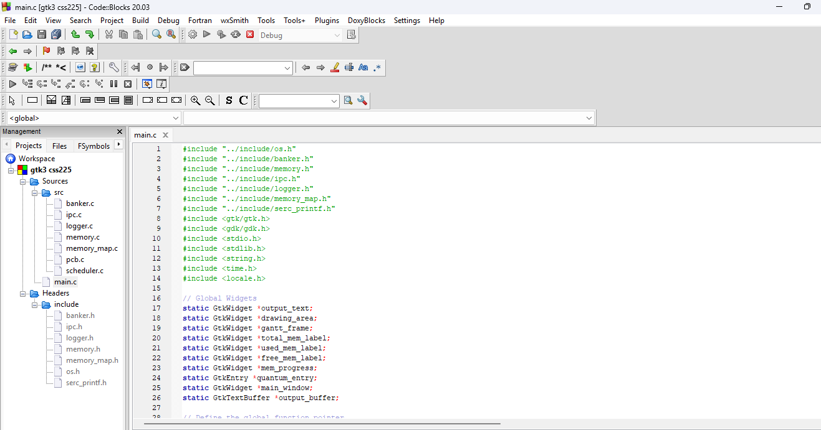

Figure 1.1: Codeblocks editor using gtk-3.0.

Creating the Installer with Inno Setup
- Install Inno Setup
  - Download from https://jrsoftware.org/isinfo.php.
  - Run the installer and follow the setup wizard.

- Prepare the Application Files
Before creating the installer, ensure:
  - The compiled gtk3 css225.exe is ready.
  - Any required DLLs (e.g., GTK dependencies) are included.
  - Optional: Add an application icon (.ico)

- Create an Inno Setup Script (.iss)
Inno Setup uses a script file (setup.iss) to define how the installer behaves.
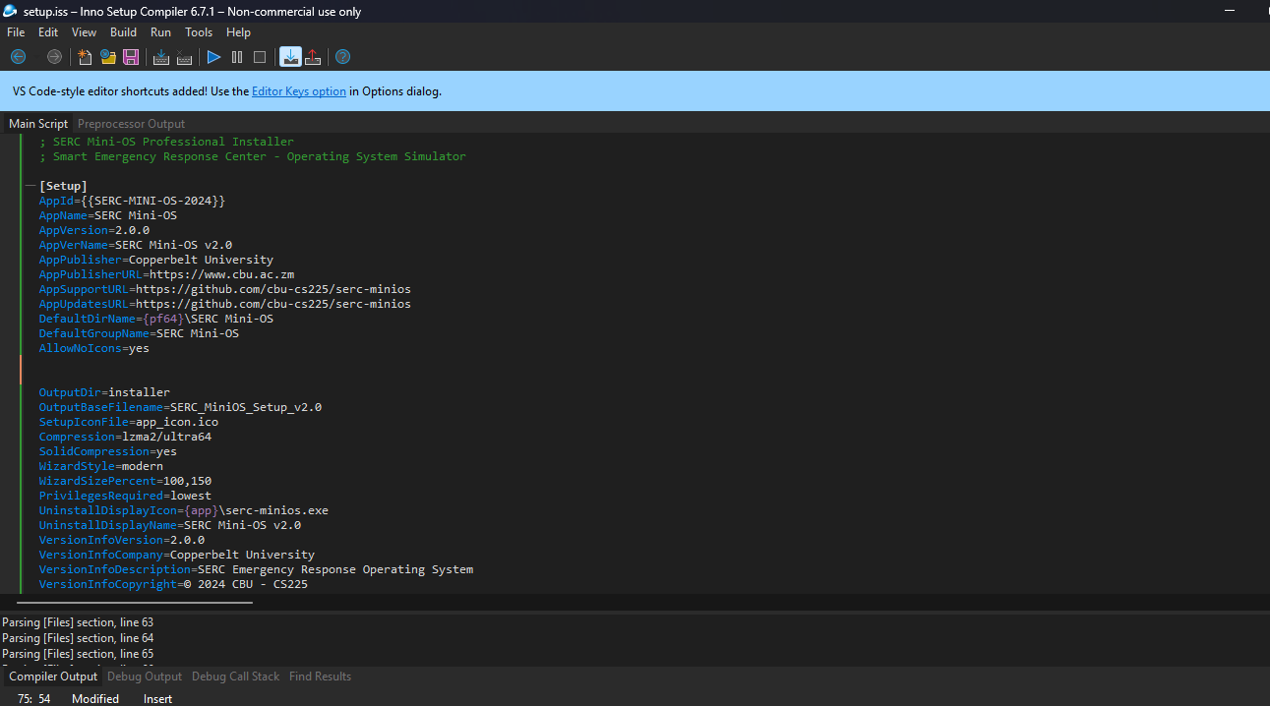

Figure 1.0.1: inno setup configurations.

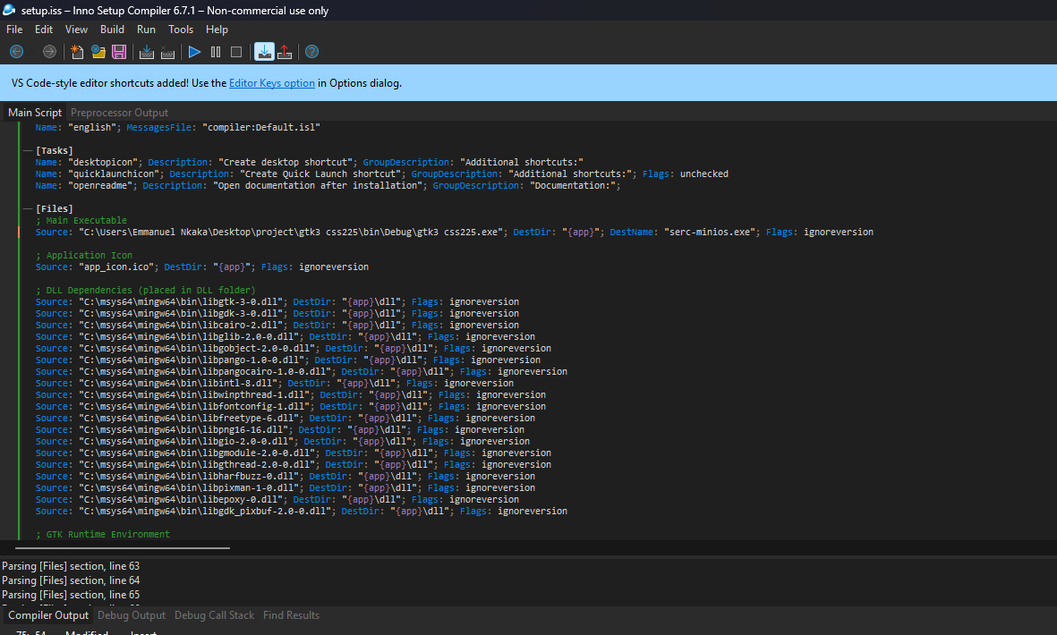

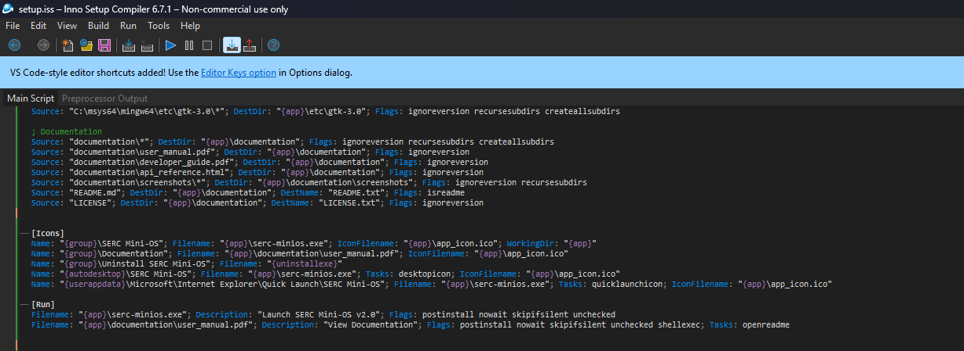

Figure 1.0.2 and 1.0.3: inno setup configurations.

Explanation of Key Sections
Section | Purpose | Key Parameters
[Setup] | General installer settings | AppName, AppVersion, DefaultDirName, OutputBaseFilename
[Files] | Specifies which files to install | Source (file path), DestDir (install location)
[Icons] | Creates Start  Menu & Desktop shortcuts | {group} (Start Menu), {commondesktop} (Desktop)
[Run] | Optional: Run app after installation | postinstall nowait (doesn’t block installer)

Compile the Installer
  - Open the .iss script in Inno Setup Compiler.
  - Click Build → Compile
  - The compiled installer (gtk3 css225.exe)

Screenshots of Execution
Main Application Window
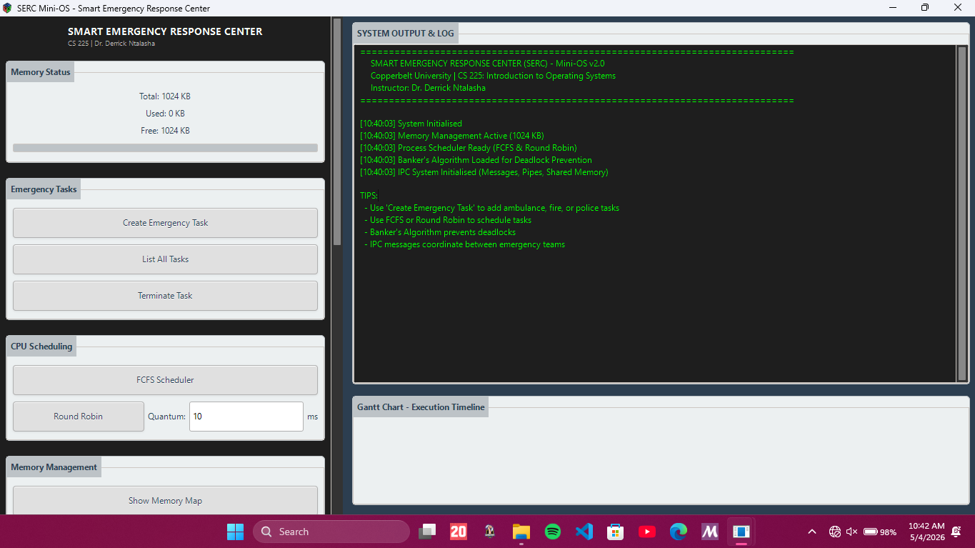

Figure 1.1: Smart Emergency Response Center start window.

FCFS Scheduler Output
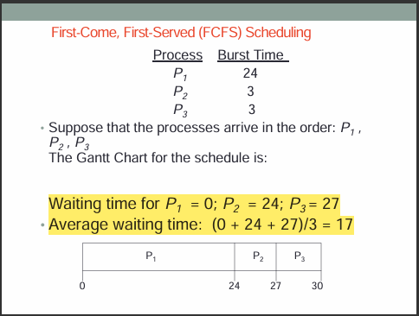

Figure 1.2 : Example of First-Come, First-Served (FCFS) Scheduling with reference from notes(CS225 UNIT 5).
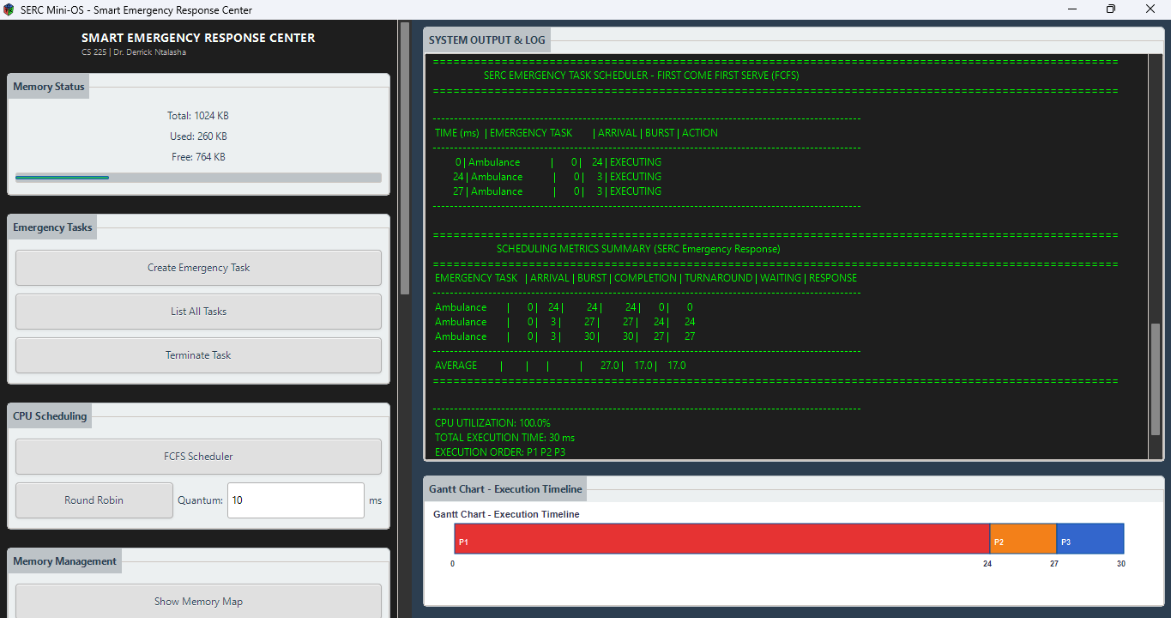

Figure 1.2.1: FCFS with output tab, Processes in this case are emergency tasks.

Round Robin
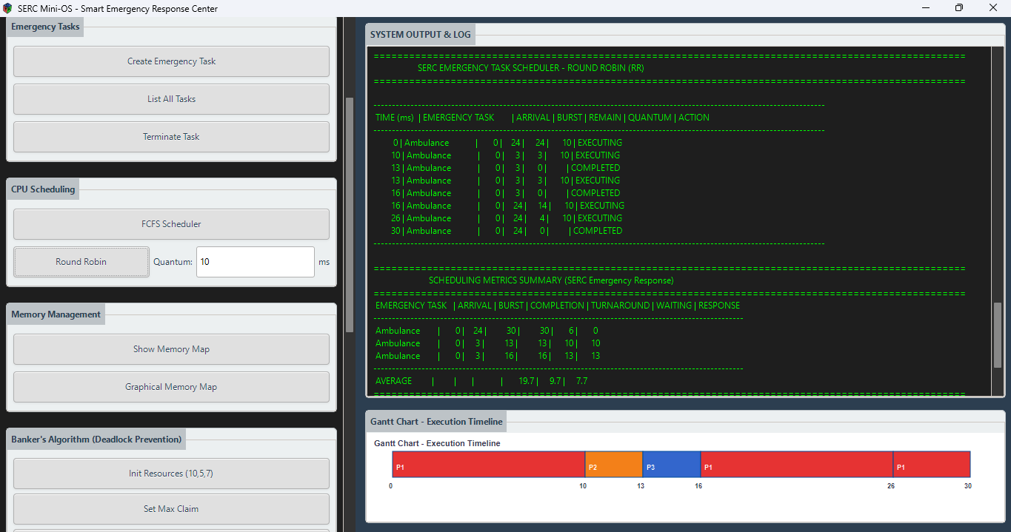

Figure 1.3.1: Round robin scheduling, with quantum of 10ms.
Banker's Algorithm Resource Status
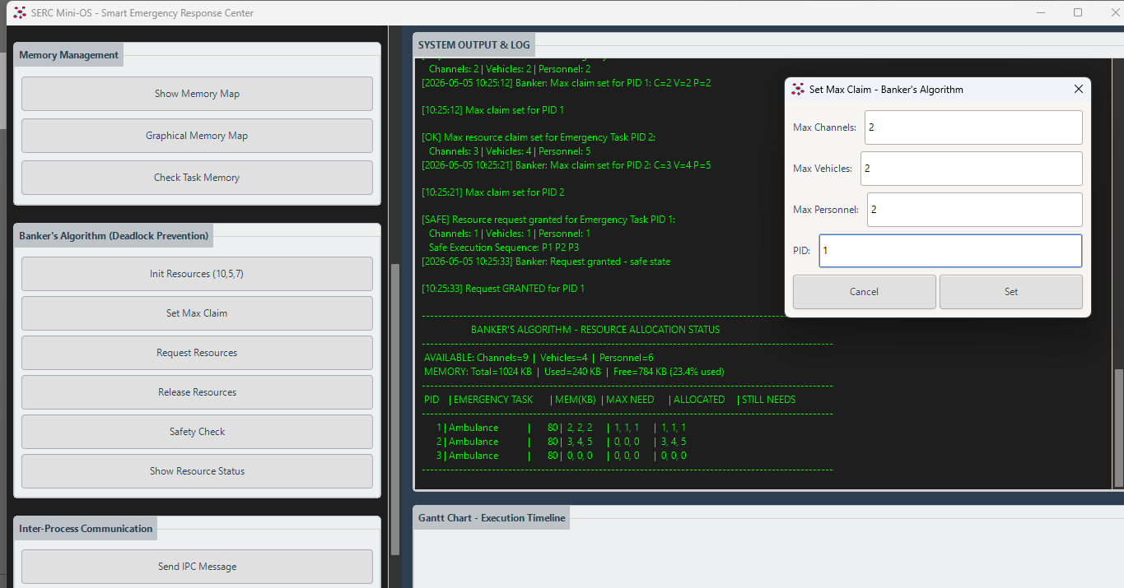

Figure 1.3.2: max needed memory set by clicking ‘SET MAX CLAIM’
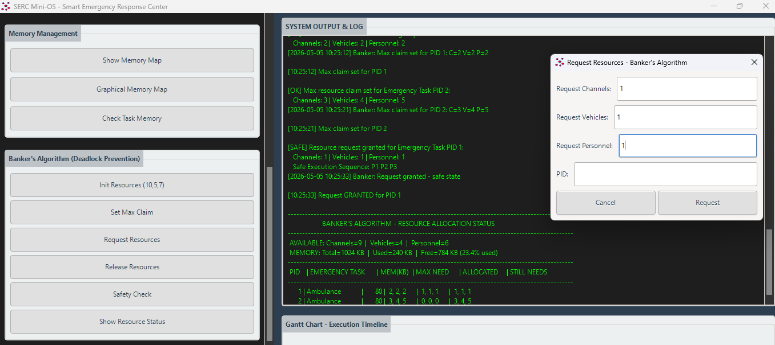

Figure 1.3.3: Request resources, setting process allocated memory set by clicking ‘REQUEST RESOURCES’

Memory Map Display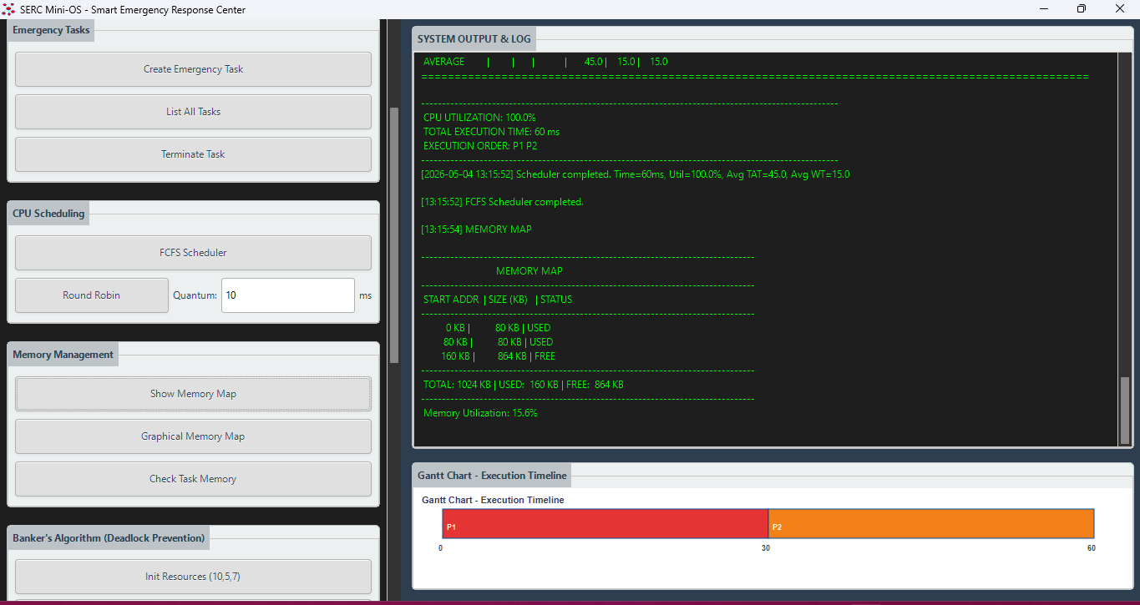
Figure 1.4: Memory display in system output and log.
Event Log Output
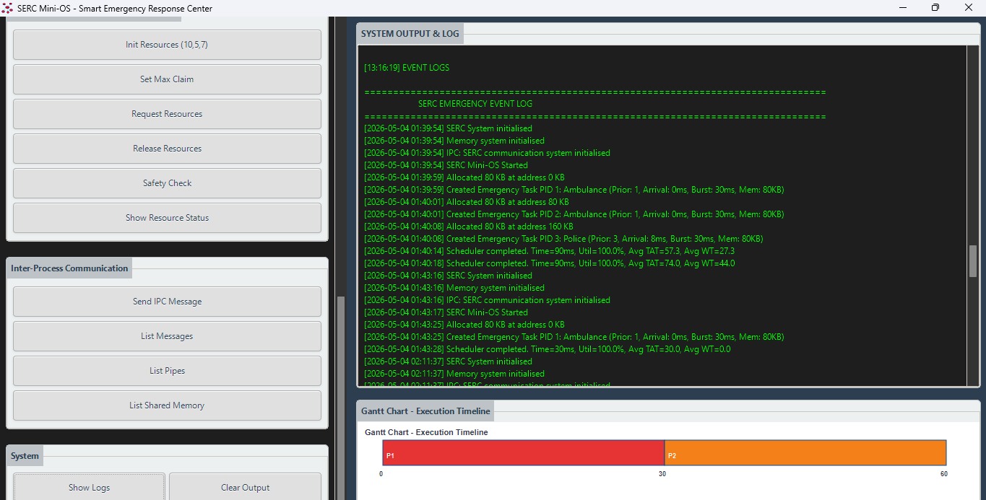

Figure 1.5: Event log in system output and log.

Expected Output
- A Windows executable (.exe) with a GUI
- An installer (.exe) that deploys the application.
- Creating Emergency Tasks
- List All Tasks Output
- FCFS Scheduler Output
- Round Robin Scheduler Output
- Memory Map Output
- Banker's Algorithm Output
- Requesting Resources (Safe/unsafe)
- Check Task Memory Output
- IPC Output

Challenges

- Scrollbar Not Appearing, Configured GTK_POLICY_ALWAYS for vertical scrollbar
- Banker algorithm (allocation button), Could not implement allocation

Current Limitations
Single-threaded Execution: All processes are simulated; no actual parallel execution
Fixed Resource Types: Banker's algorithm supports exactly 3 resource types
No Preemptive Priority Scheduling: Only FCFS and Round Robin implemented
Static Process Limit: Maximum 64 processes
No Virtual Memory: Simple contiguous allocation only
No Disk I/O Simulation: No secondary storage management
Fixed Memory Size: 1024 KB hardcoded, not configurable at runtime.

Conclusion
The SERC Mini-OS successfully demonstrates the core concepts of operating systems through an interactive, visual simulation environment tailored for emergency response scenarios. All stated objectives were achieved

Quantitative Results
Codebase Size: 800 lines of C code (main.c file)
Supported Scheduling Algorithms: 2 (FCFS, Round Robin)
IPC Methods: 3 (Messages, Pipes, Shared Memory)
Resource Types: 3 (Channels, Vehicles, Personnel)
Max Processes: 64
Memory Size: 1024 KB

